Community Meeting Notes
REZ2025-00023, Marchetti Properties, et. al.
CUP2025-00016 + SE2025-00023, VALCO Hanover County Four L.L.C.
Proposed Data Center Campus on U.S. Route 33 at the Chickahominy River

Date/Time | Thursday, October 30, 2025 (6:00 p.m.)
Meeting Location | Elmont Elementary School  12007 Cedar Lane  Ashland, VA 23005
Request | Rezoning: A-1 to M-1  CUP: Substation  SE: Buildings Taller than Permitted
Number of Attendees | Approx. 110
Board of Supervisors’ Members Present | Susan Dibble (South Anna)  Jeff Stoneman (Beaverdam)
Planning Commission Members Present | Larry Leadbetter (South Anna)  Fred McGhee (Cold Harbor)
Staff Members Present | Gretchen Biernot  Andrew Pompei
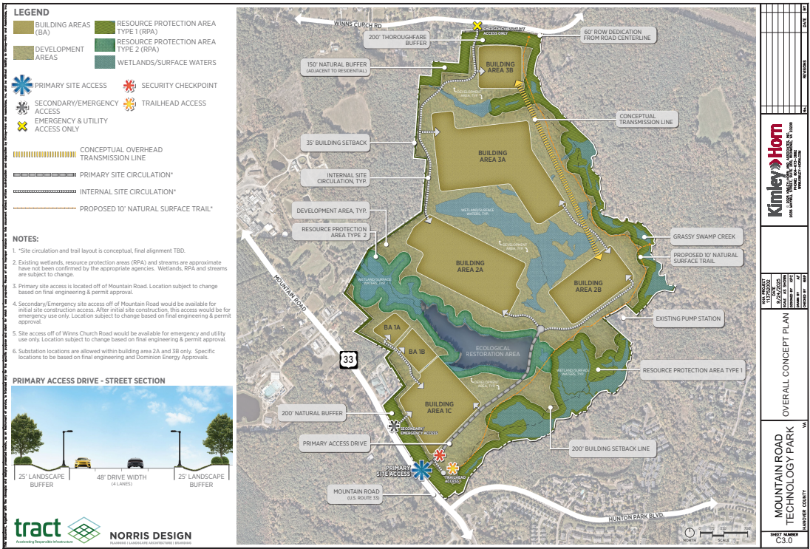

Applicant Overview
Ms. Dibble and Mr. Pompei provided a welcome/introduction. The applicant’s representative (Erin Fosdick) introduced other team members from Tract (data center company) and led a presentation/overview of the proposed project, which encompasses about 428 acres along U.S. Route 33 adjacent to the Chickahominy River. She also provided information regarding the U.S. Route 33 Small Area Plan. Another representative from Tract (Grant Pulley) provided additional information about the features shown on the conceptual plan, indicating that about 40% of the site will remain as open space (building areas cover 30% of the site). He provided information about site access and building areas. Proposed buildings will have a maximum building height of 62 to 85 feet depending on the building area, with view profiles presented that show whether buildings are visible from different vantage points along U.S. Route 33 and Winns Church Road (considering buffers that are 200 feet in width along adjacent thoroughfares). Another representative from Tract provided information about power from Dominion Energy, with an expected service date in the first quarter of 2030, with Tract responsible for all extensions of power infrastructure to the site. The applicant provided an estimated fiscal impact 15 years after construction, as well as estimates on the number of jobs. A rendering of a natural surface trail was shown to provide an illustration of the proposed trails along the Chickahominy River and Grassy Swamp Creek. The applicant created a website at www.mountainroadtechpark.com.
Public Questions/Discussion
The following questions, concerns, and responses from the applicant were addressed in the meeting:
- How big will the substation be?
  - Applicant: Each substation will be 300 MW with a footprint that is 540 feet by 450 feet, with a height of up to 25 feet. Three substations are proposed in specific building areas on the site.
- Will electricity rates increase?
  - Applicant: Dominion Energy has changed its process to ensure other ratepayers are not impacted by the infrastructure needed to serve the site. The developer is responsible for all costs to extend infrastructure to the data center campus with significant deposits put in place. Each substation costs $450 million, with the developer signing a power agreement. The State Corporation Commission also reviews costs to ensure that data center customers “pay their fair share.”
  - Citizen: Every state with data centers has experienced increased electricity rates. Dominion will likely raise rates. Dominion is also unreliable as nearby residents experience power outages all of the time. There are also outages for WiFi. How will this problem be fixed?
  - Applicant: In terms of cost and reliability, the applicant would not choose this area if they did not believe there is a reliable source of power. The substations for this project will be on a different circuit than those serving homes, schools, etc. If the power is not reliable, the data center would not be built because consistent power is needed.
  - General Comments: There are significant concerns about increasing power rates for customers and that Dominion will prioritize providing service to the data centers versus residential customers.
  - Citizen: How many houses would 900 megawatts of electricity serve for residential uses? Research indicates it is about 10,000 homes.
  - Applicant: The applicant did not know the answer.
  - Citizen: Has a deposit been paid to Dominion Energy? Is the project in the queue?
  - Applicant: A load study has been completed and a deposit has been paid for the load study. There is already an energization date for this site. A deposit of $250,000 has been paid for each substation for the initial study, with a deposit of $13 million required at the next review step.
- Where is the water coming from? Will wells be impacted? What are the water pollution implications?
  - Applicant: The project will use public water. There was a recent high-water user that was in this area that is no longer operating. The applicant will abide by all pollution prevention requirements. The project will connect to existing water mains on Winns Church Road and Mountain Road, creating a loop for redundancy. Water consumption varies by time of year, with it being consistent with residential uses. The water will be used for cooling purposes.
  - Citizen: What happens to the water after it is used as cooling?
  - Applicant: Cooling water will go into the sewage pump station that is nearby. The water is generally the same as what arrives at the site but is slightly more concentrated. It is the same composition as what comes into the site, but some evaporation occurs that makes some minerals concentrate.
  - Citizen: How much water will be used?
  - Applicant: Water usage is correlated with megawatts.
  - Citizen: Will rainwater be captured for reuse?
  - Applicant: Stormwater management practices will comply with state stormwater management requirements. An agreement for water supply with Hanover County would just be for usage. Enough water has to run off the site to supply local water bodies downstream.
  - Citizen: There are concerns about Hanover County purchasing water from the City of Richmond and the data center being prioritized for water if there is another water issue.
  - Applicant: Information about expected water usage will be available on the project website in the coming weeks.
- What would the maximum building square footage be?
  - Applicant: The applicant correlates building size to water usage and energy usage.
- Will these buildings be two- or three-story data centers?
  - Applicant: The two-story buildings will be up to 62 feet, with the three-story buildings being up to 82 feet. There will be a mix of two- and three-story buildings.
- What research has been done to determine if the project will impact well water? Wells have been impacted in other areas.
  - Applicant: The project will connect to public water. Stormwater management facilities will be designed to meet state requirements. In other areas, neighbors have been impacted by improper construction techniques, not by the data center development itself.
- When will these buildings be built? Will there be demand for data centers then? What happens to the buildings if the data centers are no longer needed?
  - Applicant: There is demand for these facilities due to significant online usage.
- Is VDOT going to widen U.S. Route 33? Will a traffic signal be installed at U.S. Route 33/Winns Church Road?
  - Applicant: Turn lanes will be constructed at the project entrance. The project will not generate a need for a signal at U.S. Route 33/Winns Church Road.
  - Citizen: There is a serious accident every four weeks along Route 33, which causes backups. There is traffic congestion in the mornings and evenings. The proposed project does not effectively mitigate traffic.
- Once one rezoning is approved, more rezonings will be approved. U.S. Route 33 is designated for light industrial development within the Hanover County Comprehensive Plan.
- What will the noise impacts be? There should be more analysis and explanation regarding the noise concerns.
  - Applicant: There is a noise ordinance that must be complied with. There are a variety of noise attenuation techniques that can be used to reduce noise.
- How would a gated emergency entrance on Winns Church Road be accessed during an emergency?
  - Applicant: There is a lock box emergency responders have codes or keys for access. It is a common practice.
- Where is there a data center that is comparable in size that has three substations in Virginia?
  - Applicant: There are similar-size facilities in Northern Virginia, but there is less land area. White Oak Technology Park in Henrico County has data centers that may be an accurate representation of what will be built on this site.
- There is currently only one pond. Will you build more?
  - Applicant: The blue areas are existing wetland areas.
- Substations generate electromagnetic fields (EMFs).
  - Applicant: Data centers do not generate any EMFs. The substations do not have radical ions. At the property lines, there are no EMFs from the substations per scientific tests. Reputable studies demonstrating this will be researched.
- How much noise do generators make?
  - Applicant: Generators must abide by local and state ordinances.
- What are the building setbacks?
  - Applicant: There is a 200’ building setback along Winns Church Road and Mountain Road.
  - Citizen: There are concerns about there being visibility when leaves fall off the trees.
- Can there be more engineering studies about how far noise will be heard? How tall are the trees and how long do they take to grow? Most of the questions relate to engineering issues.
  - Applicant: More specific feedback will be provided on the project website. Not all of the details are known now, since the project is not at site plan review.
- Will there be any incentives for this project provided by the County?
  - Applicant: No.
- The plan mentions fuel storage and water treatment. What do they mean?
  - Applicant: If the cooling water needs further treatment, some water treatment would be provided. There is fuel storage for the generators.
- How much revenue will this project generate? Hanover County needs more businesses to provide more tax revenue, helping alleviate tax burdens. Residential uses create tax burdens.
- Will there be another community meeting? Do you know when the Planning Commission public hearing will be scheduled?
  - Applicant: Another community meeting has not yet been determined. The public hearing for the Planning Commission has not yet been determined, as staff comments have not been received.
- How much more land do you plan to buy? How would the project connect to the transmission lines? Access to a transmission line would require more land.
  - Applicant: We do not plan to buy more land.
- Is there any discharge into the Chickahominy River?
  - Applicant: Stormwater would be discharged to the Chickahominy River.
- What is the purpose of the pump station?
  - Applicant: There is an existing public sewage pump station.
- What would the estimated 300 employees working in the data center be doing?
  - Applicant: There is a variety of jobs at different salaries and skill levels.
  - Citizen: Can a certain number of jobs be reserved for Hanover County residents?
  - Applicant: It is too early in the process to determine who will be employed on-site.
- Concerns were noted regarding generator noise (including limiting testing to weekdays), building orientation, light, visual impacts from taller building heights, and other potential impacts the project may have on the property to the east along Grassy Swamp Creek, which is designated for residential development.
- Why do you want to locate this project in Hanover County and Virginia, where there is already a proliferation of data centers?
  - Applicant: Infrastructure to support the internet started in Northern Virginia (related to national security and proximity to Washington, D.C.). In Hanover County, there is available power, and there are areas designated for data center uses.
- Do data centers have a lifespan?
  - Applicant: The equipment within the data centers has a lifespan, which influences personal property tax rates.
- Is there anything that would prevent data centers from expanding outside of the development area?
  - Applicant: The development areas cannot be expanded without a proffer amendment (zoning review and change).

