Board of Supervisors

W. Canova Peterson, Chairman  Mechanicsville District | 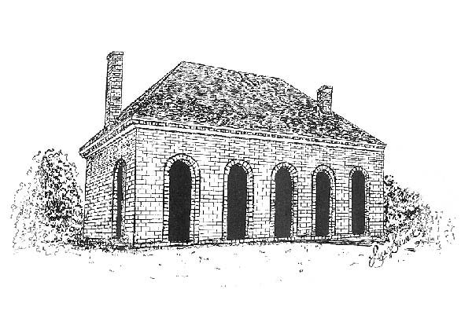Hanover Courthouse | Department of Public Works
Scott A. Wyatt, Vice-Chairman  Cold Harbor District |  | J. Michael Flagg, P.E., Director  W. R. Hardman, III, P.E., Deputy Director
Sean M. Davis  Henry District |  | P.O. Box 470  7516 County Complex Road
Wayne T. Hazzard  south anna District |  | Hanover, Virginia 23069  Phone: 804-365-6181
Angela Kelly-Wiecek  chickahominy District |  | Fax: 804-365-6233  www.hanovercounty.gov
HANOVER COUNTY
Established in 1720

Faye O. Prichard  ashland District | HANOVER COUNTY  Established in 1720 | Cecil R. Harris, Jr.  County Administrator
Aubrey M. Stanley  beaverdam District | HANOVER COUNTY  Established in 1720 | Frank W. Harksen, Jr.  Deputy County Administrator
October 17, 2019

MTL Development, LLC
ATTN: David Martin
11250 Central Drive
Ashland, VA 23005

RE: Wood Park Court Multi-Tenant Warehouses
Public Works Site Plan Review – Owner’s Letter
SPR # 4-19
PZ # 19-30000014
BP # 19-09900033
E&S # 5480

Dear Owner:

This office has completed its review of the plan referenced above, and we are now recommending Technical Approval. Plans will not be “Approved” until the Land Disturbance Permit is issued. At this time, the following items need to be addressed before this office can issue a Land Disturbance Permit for this project:

X The Plans need to be approved by the Planning Department
X The applicable Land Disturbance Permit Type for this project is Land Disturbing Activity 10,000 square feet or greater (valid for 12 months)
X _ The Erosion and Sediment Control Inspection Fee has been set at $2,533.68 (6.28 acres of land disturbance at $612 base fee plus $306/acre).
X The Owner/Applicant must post the Erosion Control Bond amount of $39,219.00 using the County’s standard forms. This Bond may be in the form of cash, irrevocable letter of credit, or surety. Note: Surety requires the first $20,000.00 to be in the form of cash bond or letter of credit.
X Prior to issuance of the Land Disturbance Permit the Owner/Applicant must obtain a VSMP Permit. This will require a separate payment that will have to be made to Virginia DEQ before the VSMP permit can be issued. [termination and SWPPP documents if applicable]
__ A bill of sale from the DEQ approved non-point source Water Quality credit vendor must be provided to document the off-site nutrients credits have been purchased as specified on the approved plans.

[Note that for any stormwater BMPs associated with this project, the Owner must submit a construction record drawing that has been signed and sealed by a professional registered in the Commonwealth of Virginia certifying that the BMP(s) have been constructed in accordance with the plan. Typically, inspections must take place during construction of the BMP in order for the registered professional to provide this certification.] PLEASE NOTE THAT NO CONSTRUCTION ACTIVITIES CAN TAKE PLACE UNTIL YOU OBTAIN A LAND DISTURBANCE PERMIT FROM THE DEPARTMENT OF PUBLIC WORKS.

Sincerely,

Nicole Onellion, E.I.T.
Civil Engineer I
Department of Public Works

